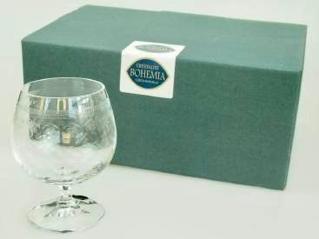
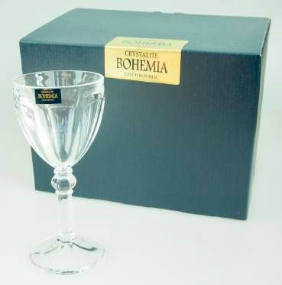
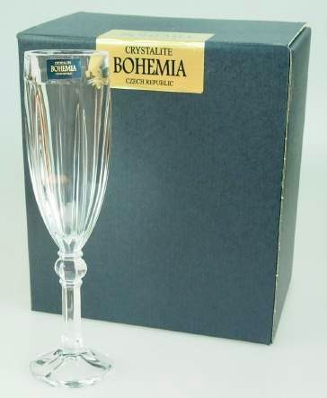
item nr photo Description qty EURO

9K7/1KD02/0/99T52/
160-669
set of 6 champagne flutes ROBIN 160 ml CRYSTALITE BOHEMIA, size of the box
20x13,5x22,5cm 419 €

4,17

9K7/1KD02/0/99T52/
200-669
set of 6 wine glasses ROBIN 200 ml CRYSTALITE BOHEMIA, size of the box
25x16,5x18cm 869 €

4,17

281/1S010/0/P0337/2
50-669

set of 6 brandy glasses 250 ml CRYSTALITE BOHEMIA, size of the box
27x18x12cm 176 €

3,78

 | 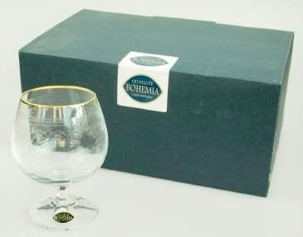 | set of 6 brandy glasses 250 ml
431/1S010/0/Z2146/2  50-669 |  | CRYSTALITE BOHEMIA, size of the box  27x18x12cm | 31 | € | 4,17
910/1S170/0/00000/0  60-000 | 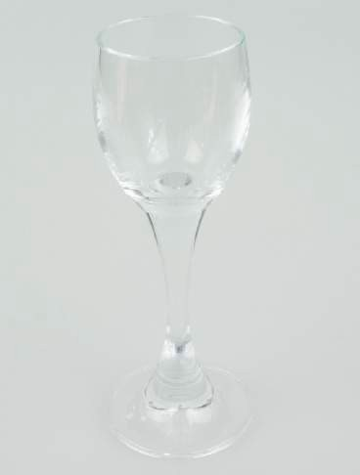 | liqueur glass ADELE 60ml CRYSTLAITE BOHEMIA | 1626 | € | 0,65
 | 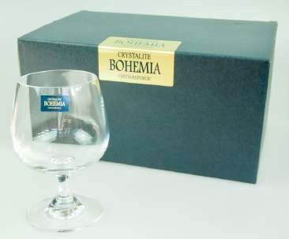 | set of 6 cognac glasses ADELE 250 ml
910/1S170/0/00000/2  50-669 |  | CRYSTALITE BOHEMIA, size of the box  26x17x13cm | 2408 | € | 4,17

